**Player Analysis**

*Pete Crow-Armstrong*

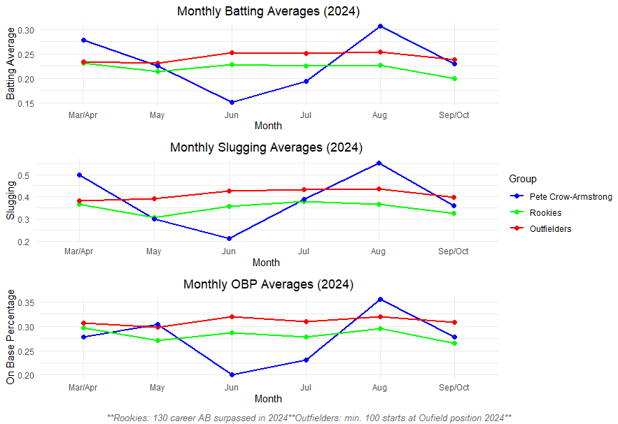

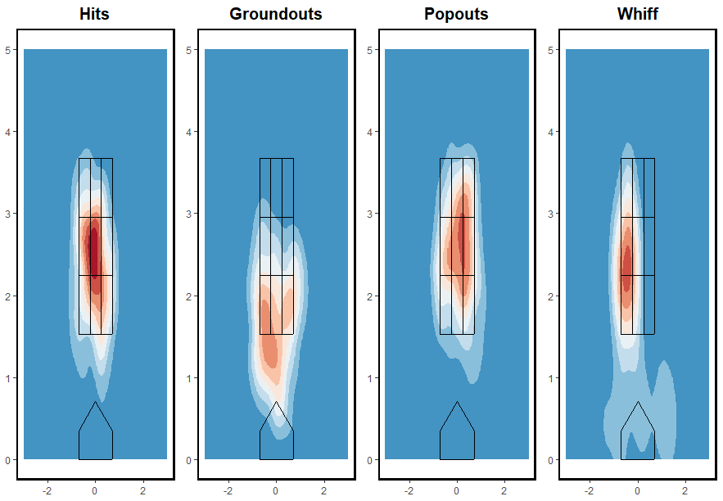

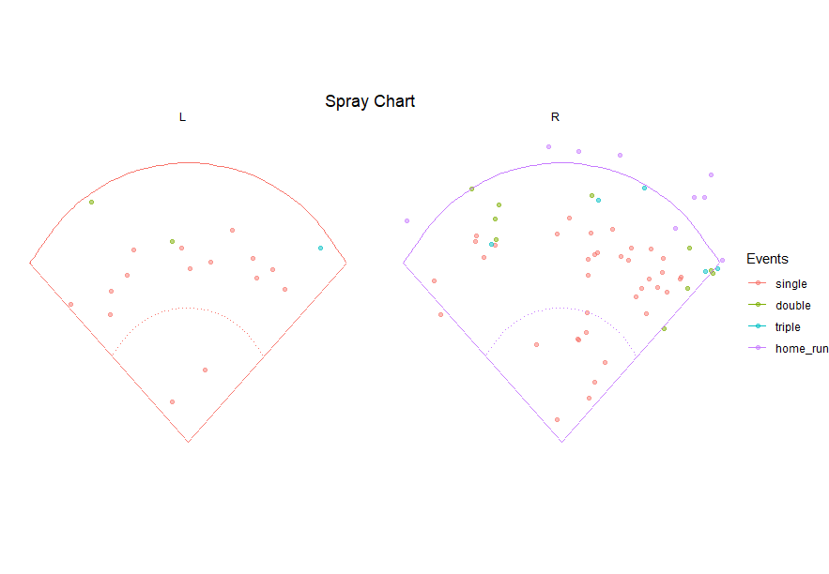

Pete Crow-Armstrong(PCA) is sought to be a future cornerstone for the Chicago Cubs. As an elite center fielder he makes an immediate impact on the roster with his athleticism, speed, and defensive ability. While he is a great prospect for the future his rookie year was full of ups and downs throughout the year. He had below average months in June and July in BA, Slug., OPB, in comparison to all outfielders and all rookies this year, while having an incredible August as seen in the first visual.

His heatmaps show his hits, groundouts, popouts, and whiffs concentrated in certain areas. While highlighting his strengths and potential weaknesses. While his hits and whiff heatmaps suggest he has a tendency to attack inside pitches. While showing tendencies to groundout to lower pitches in the zone and pop out to pitches away.

Against right hand pitchers, PCA shows tendencies to pull the ball indicating aggressiveness on inside pitches. While against left hand pitchers it is much more spread out evenly, sometimes struggling to pull the ball against lefties with a significant drop in extra-base hits, suggesting a split issue for him while struggling against lefties.

In conclusion, PCA's defense determines his value right now alone. His offensive adjustments will determine his overall impact. With his development of at bats against lefties as well as pitch location recognition.